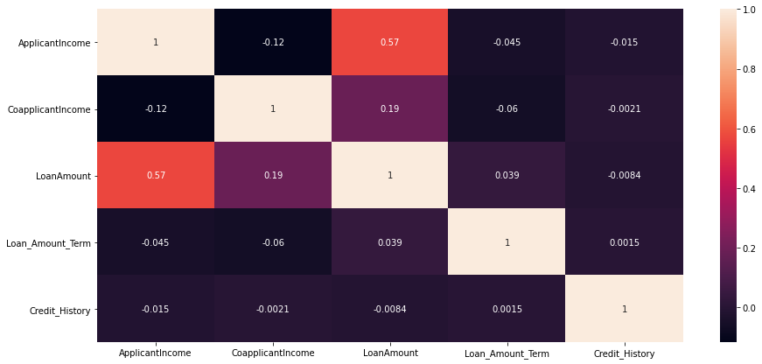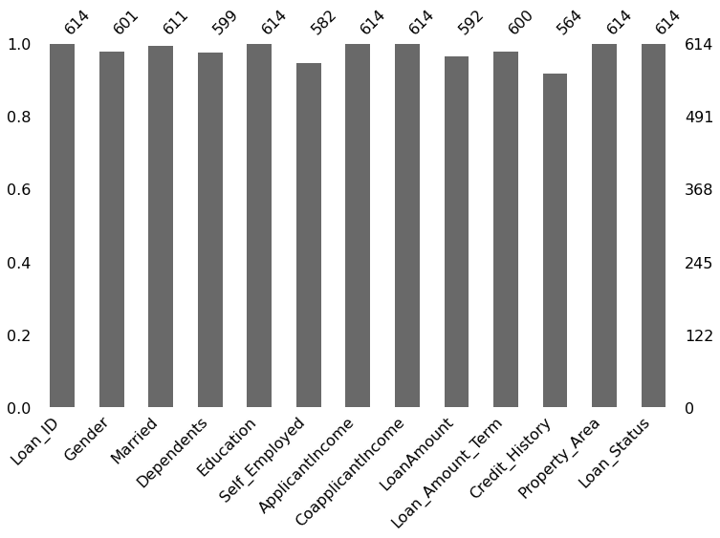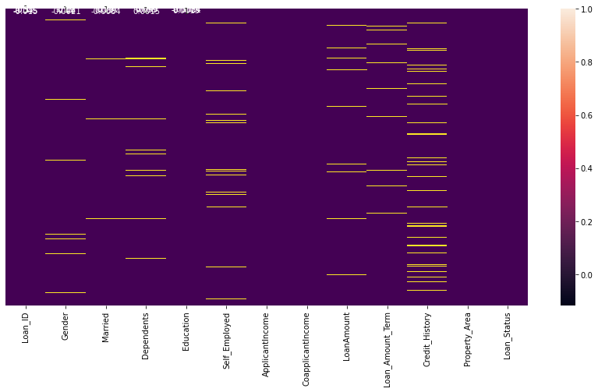

1. Heat map of pair wise data correlation between the columns excluding the Nan values.

2. Bar Plot for number of missing values in each column.

3. Heat map for missing values in all the columns.

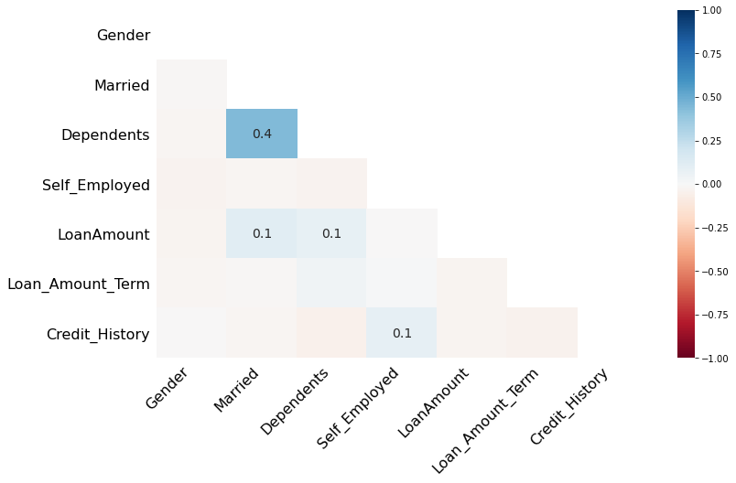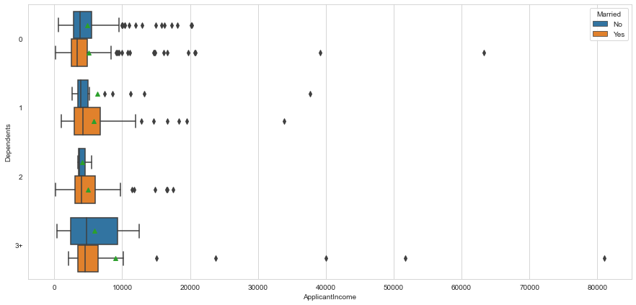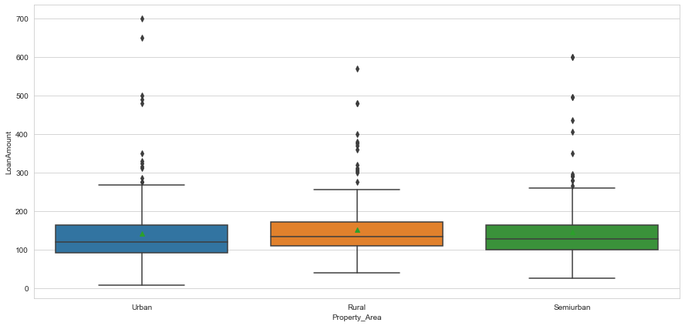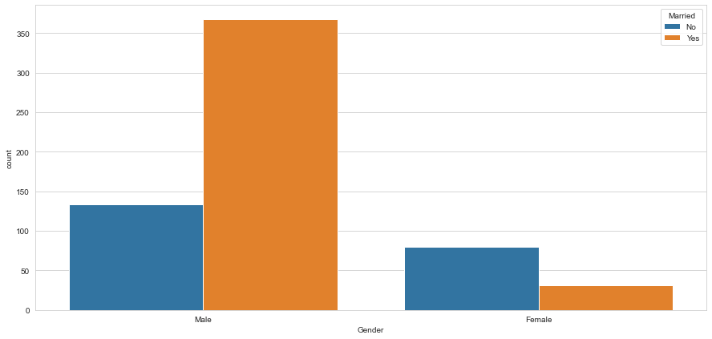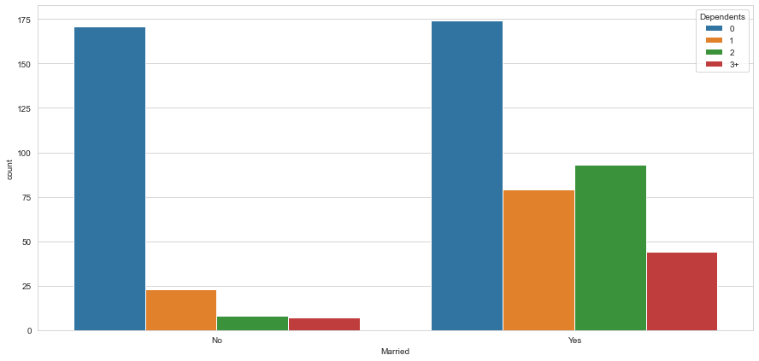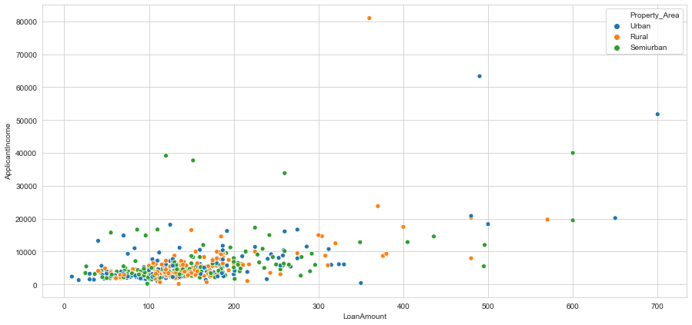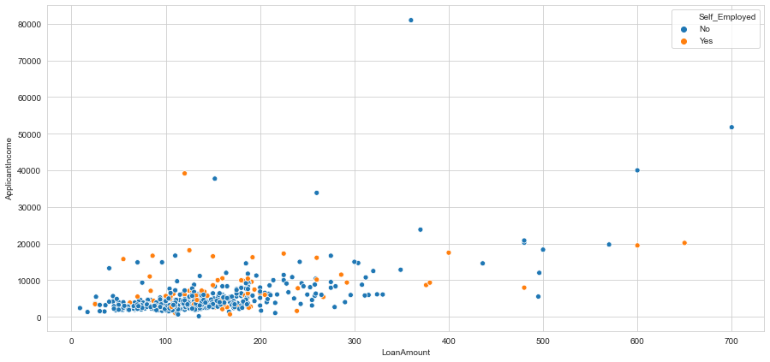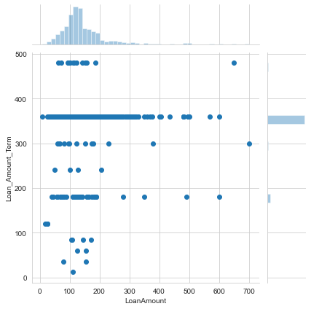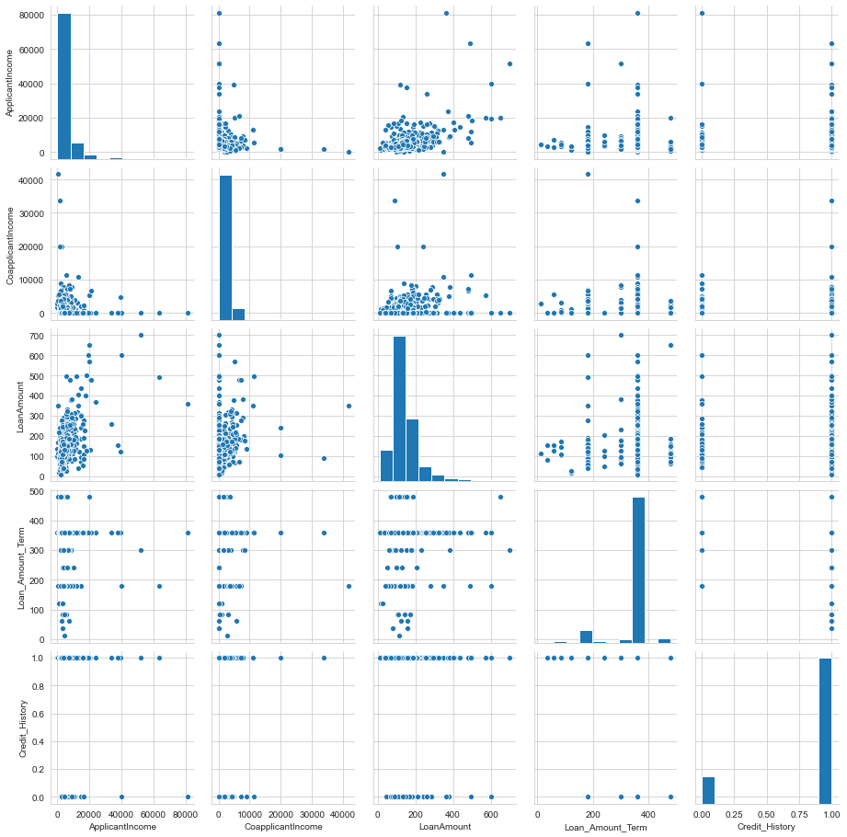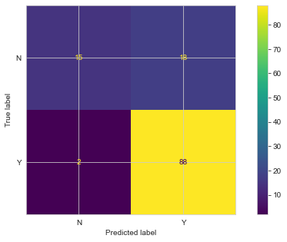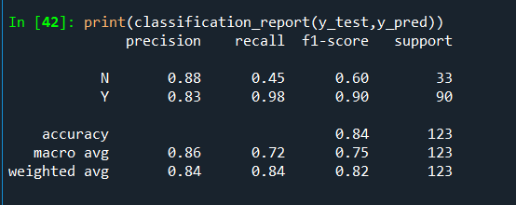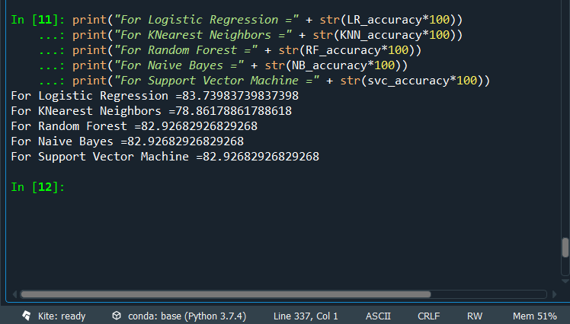

4. Heat map of pair wise data correlation between the columns of Nan values.

5. Box Plot of dependents VS applicant income with marriage as an criteria.

6. Box Plot of property area VS loan amount.

7. Count Plot of married or unmarried people based on gender.

8. Count plot of dependents based on marital status of applicants.

9. Scatter Plot of loan amount applied according to the applicant income and property location.

10. Scatter Plot of loan amount VS applicant income based on the self-employment status.

11. Joint plot of loan amount VS loan amount term.

12. Pair plots to visualize the relationship between each variable.

13. Confusion matrix.

14. Classification report.

15. Accuracy achieved for various ML algorithms.

1